ECE 5470 Computer Vision Lab7 report

Part A

Weiran Wang

NetID: ww463

## Hand written numbers:

To get started, I created a new set of 60 images of characters:

50 of these are the digits 0-9 handwritten and 10 of these are English characters. I photographed these hand written characters and convert them from png files to vx files to further process the images. The images are processed in the following way. First, I threshold the image with vit.c which gives us the figures in black background. After thresholding, I cut the characters from the image by find the leftmost, rightmost, upmost and downmost white pixels in the image, and these four coordinates give us the boundary of the character. We now have , and I used vimag command to shrink the size down to 20*20*1, last but not least, the images were centered in a 28x28 image by computing the center of mass of the pixels, and translating the image so as to position this point at the center of the 28x28 field.

Fig1. Hand written characters

To perform these data process, I created a bash script to run all the c program and command for each of the image. As you can see vfmt is to convert a image from png to vx, vits is to threshold the image, boundary is the c program cutting the characters from the background. Add is the center of mass program embedding a 20*20 image to 28*28. And the evolution of the image can be seen in fig2, fig3, fig4.

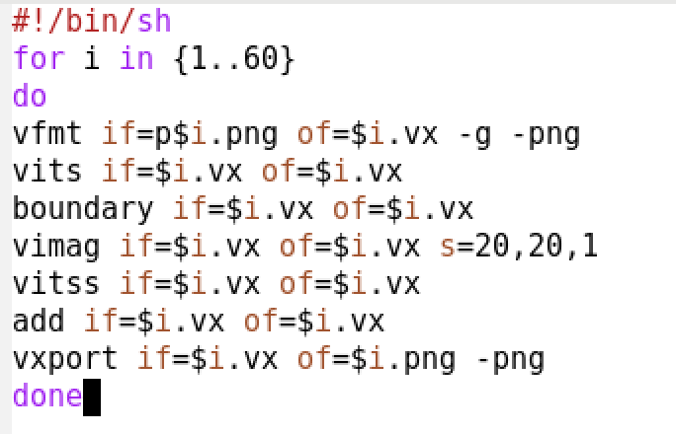

Fig2. image before & after thresholding

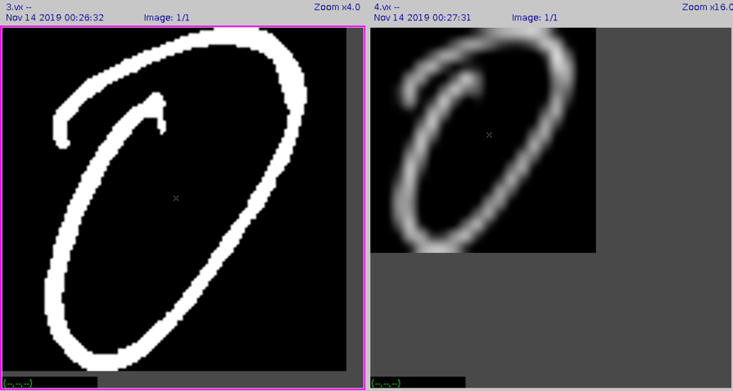

Fig3. image rescaling

Fig4. Image center of mass

Fig5. Hand written dataset

